Name:________________________________________ Unit:_________________________ Date:_________ Pd:___
Generating an Action Potential – Creating a Nerve Impulse
CP A & P
Pre-Activity Questions:
1) Define voltage (potential):

2) Define “action potential” (nerve impulse):

Event Description and Millivolt Graph (if applicable) | Diagram (if applicable)
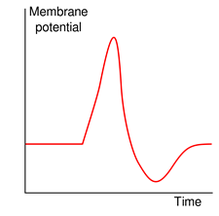  Resting: | Na+/K+ Pump at Work
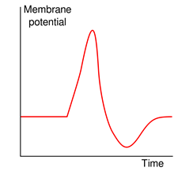  Still Resting | Voltage Gated Channels:
Depolarization:

Repolarization:

Hyperpolarization:

Resting Again:

Requirements:
-A description of an event (stimulus) that causes an action potential to initiate
- A description of the “all or none” phenomenon (threshold included in explanation)
- A description of how an action potential is propagated along a neuron
- A description of the job of all the ion channels before and during an AP (cause and effect)
- Include locations of where all of the events will take place
- A description of what happens once the action potential reaches the axon terminal

