Name:_______________________________________ Unit:_________________________ Date:_________ Pd:___
Practice: Directional Terms and Anatomical Planes
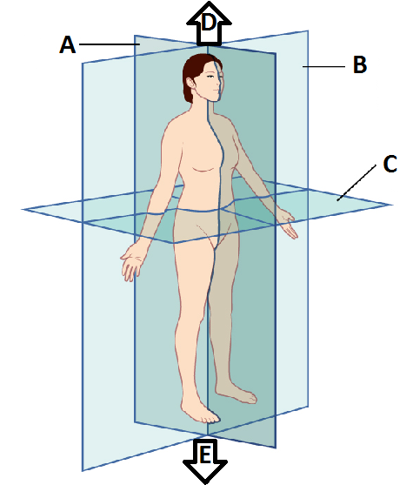
CP Anatomy and Physiology

F
G
H
I
Match the terms below with the letters from
the diagram.

Body Planes:
L
M

Mid-sagittal (Median):______

Frontal (coronal):______

Transverse:______

Anatomical Directions

Distal:______

Proximal:______

Medial:______

Lateral:______

Superior:______

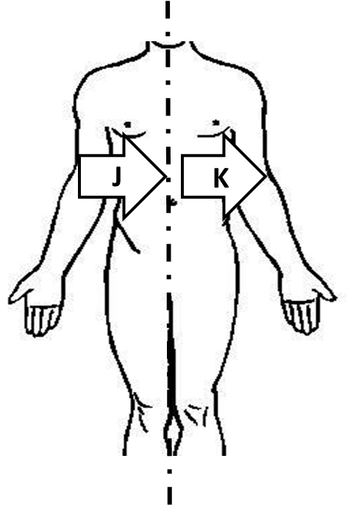
Inferior:______

Anterior:______

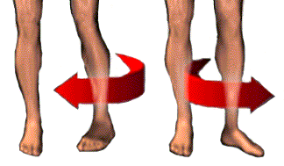
Posterior:______

Medial Rotation: ______

Lateral Rotation:______

Define the following terms:
Body Planes:

Mid-sagittal (Median):

Frontal (coronal):

Transverse:

Anatomical Directions
Distal:

Proximal:

Medial:

Lateral:

Superior:

Inferior:

Anterior (ventral):

Posterior (dorsal):

Medial Rotation:

Lateral Rotation:

