Name:______________________________ Unit:_________________________ Date:_________ Pd:___
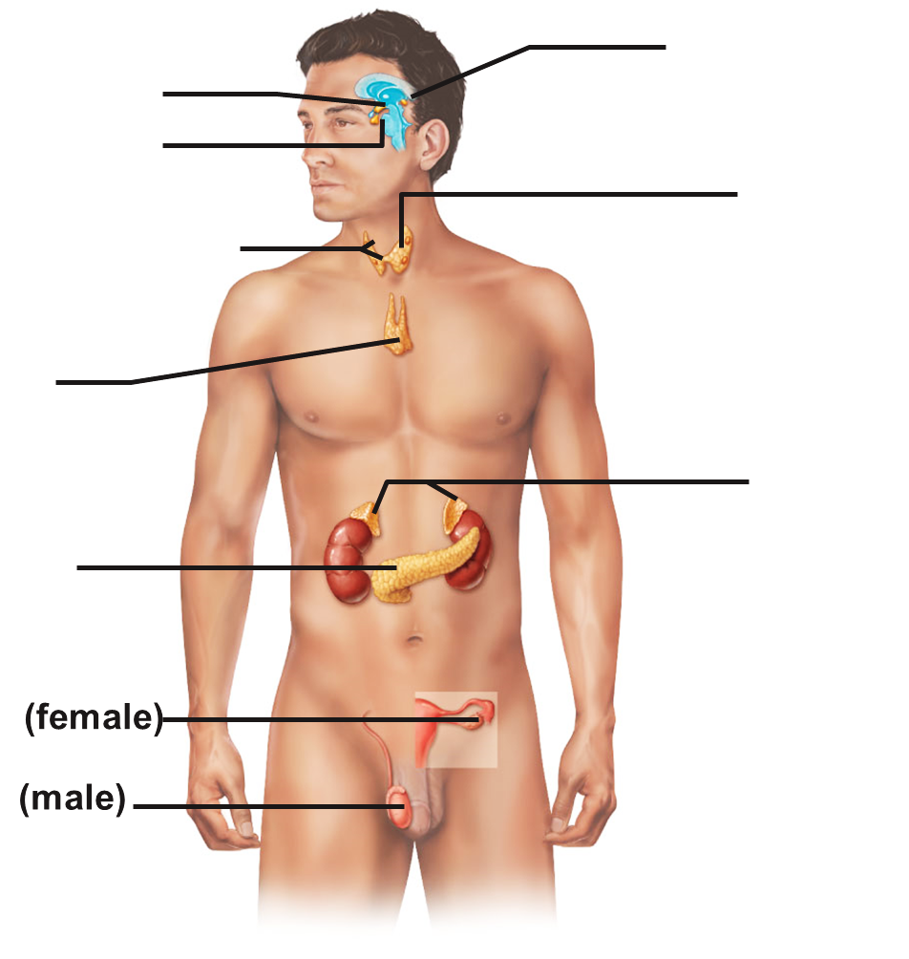
Guide: The Endocrine System
1)
CP A & P
2)
Procedure
3)
4)
5)

6)

7)

8)

9)

10)

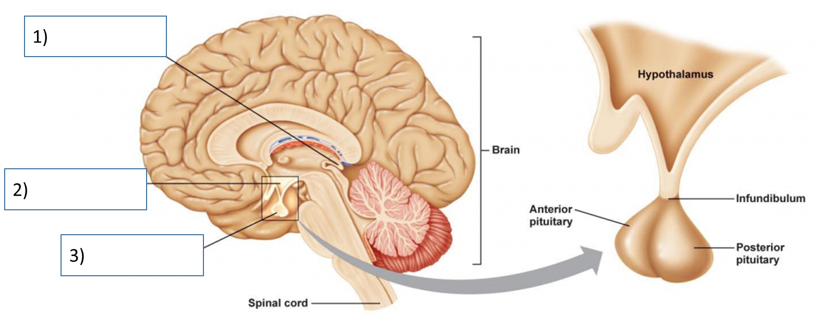

Endocrine Gland: | Major Hormone(s): | Effect(s) on Body (Description of feedback loops if necessary
1)

2)

3) | GH (Growth Hormone)
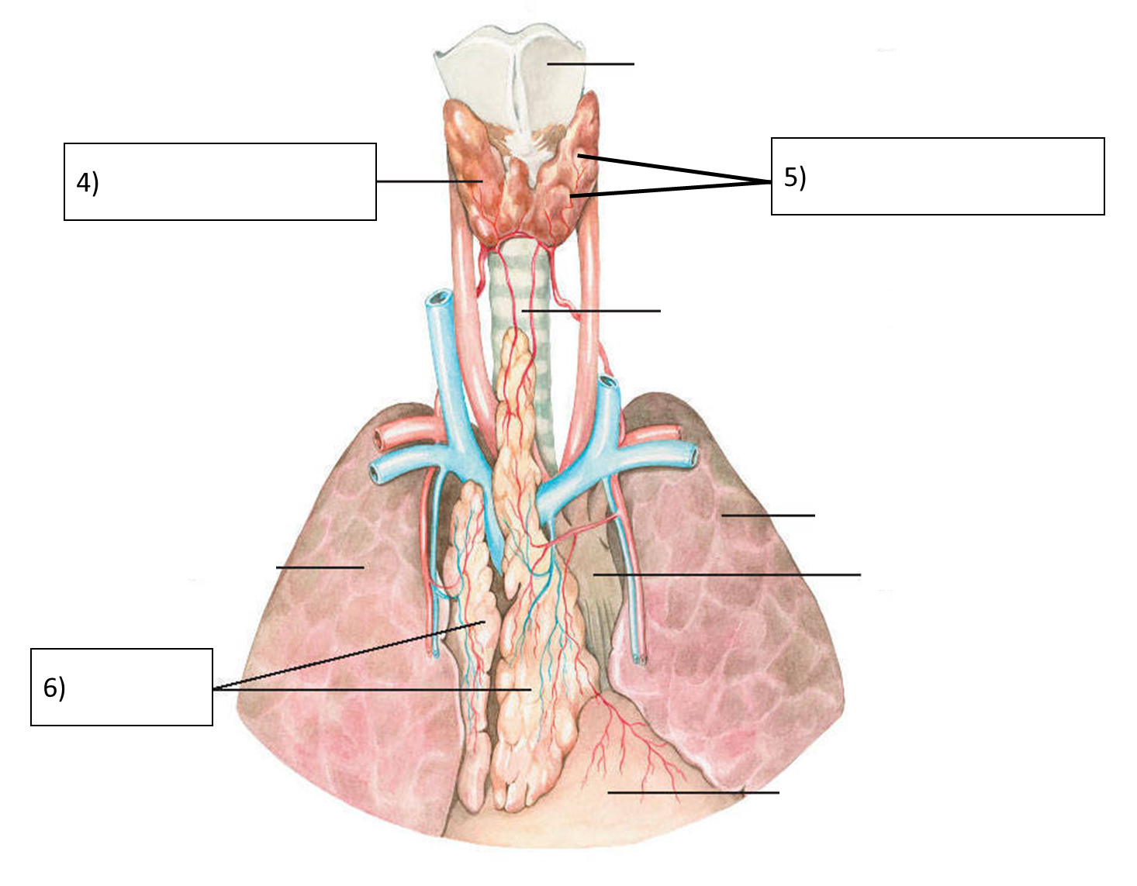

Endocrine Gland: | Major Hormone(s): | Effect(s) on Body (Description of feedback loops if necessary
4) | -  -
5) | - PTH
6)

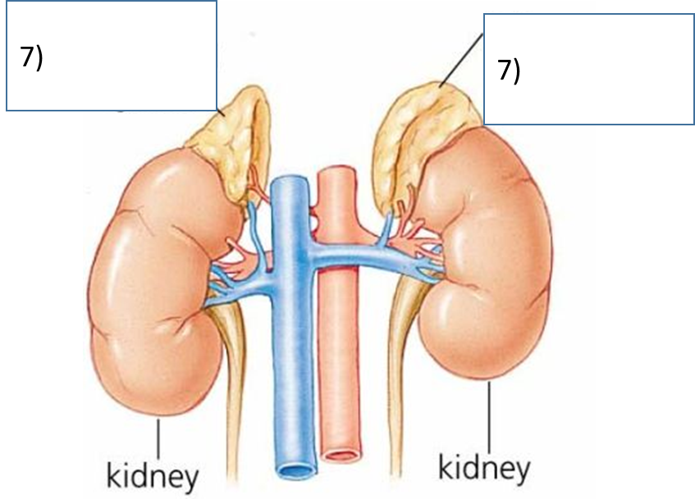
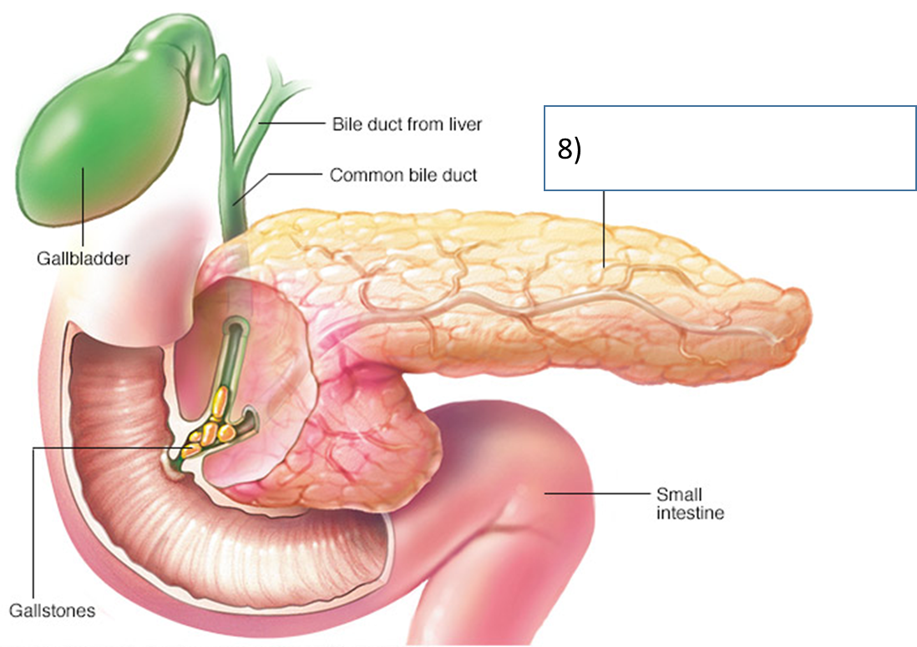

Endocrine Gland: | Major Hormone(s): | Effect(s) on Body (Description of feedback loops if necessary
7) | - Cortisol
7) | - Adrenalin (Epinephron) and Norepinephron
8) | Endocrine Hormones(Name 2)
8) | Exocrine Secretions (Name 2)
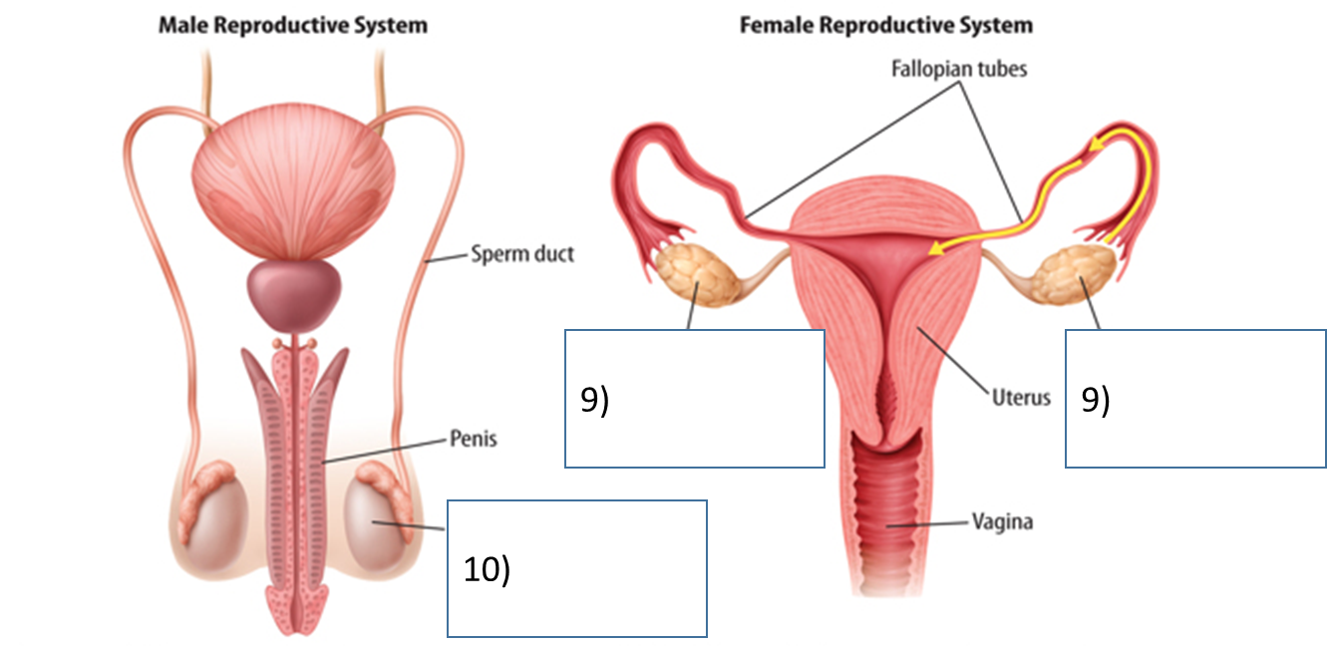

Endocrine Gland: | Major Hormone: | Effect(s) on Body (Description of feedback loops if necessary
9)

10)

