Name:________________________________________ Unit:_________________________ Date:_________ Pd:___
Practice: The Heart’s Conduction System
CP A & P
The basics:
- ____________________________________________________ (nodal system)
  - A network of noncontractile (autorhythmic) cells that initiate and distribute impulses to coordinate the

________________________ and _________________ of the heart.

Structure of Electrical Conduction System | Description of Event | Location Within Heart (Highlight)
1) |  | 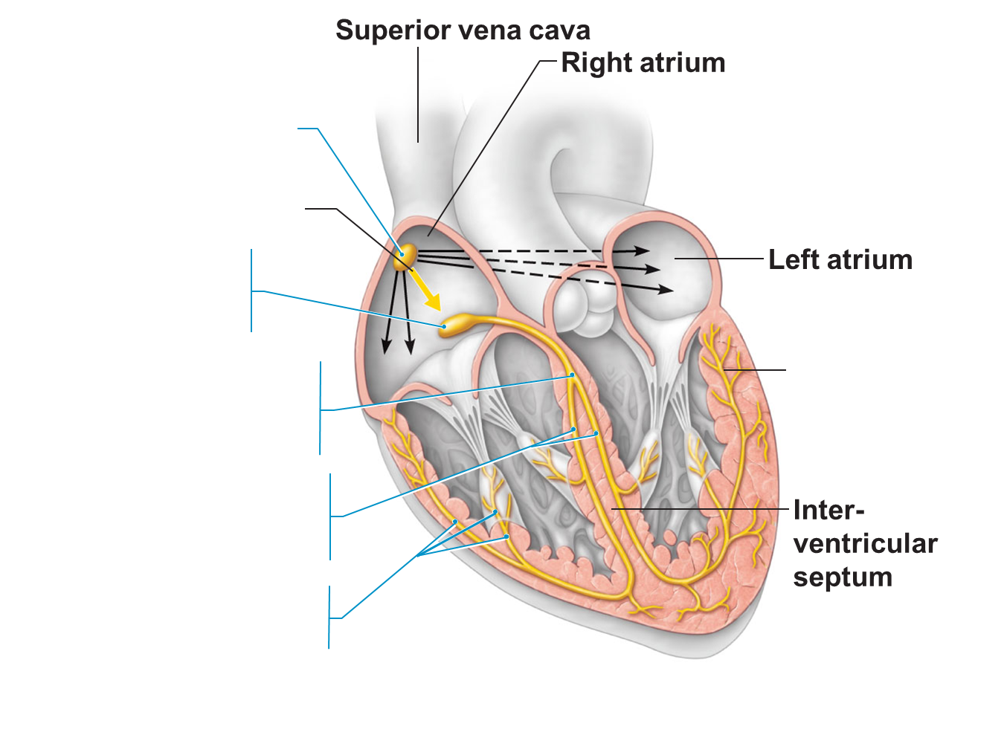
2) |  | 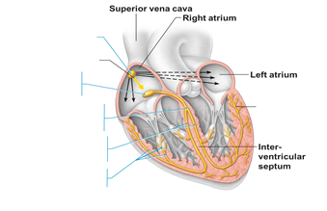
3)

4)

5)

Electrocardiography
- Electrocardiogram (ECG or EKG): a composite of all the ____________________________ generated by _________________and _____________________________at a given time
- Three (main) waves
  - P wave:

  - QRS complex:

  - T wave:
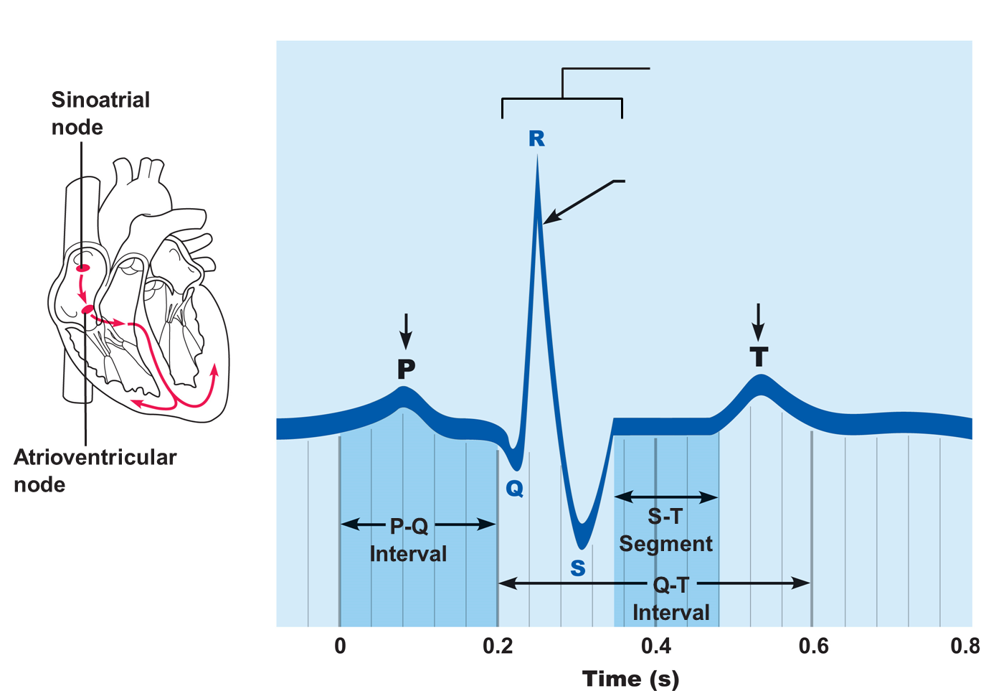
Add the
missing
wave
labels.

Heart Sounds:
- Two sounds (lub-dup) associated with closing of __________ __________
  - First sound occurs as
  - Second sound occurs when

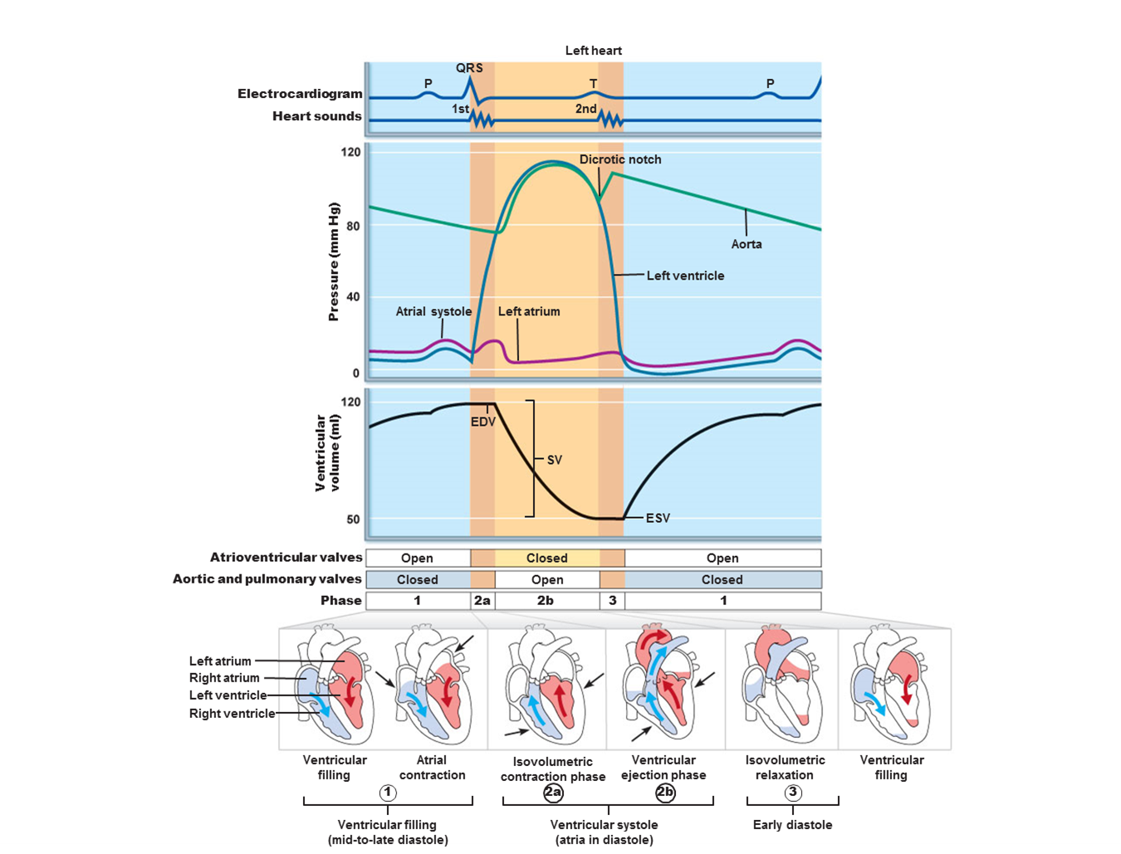
- Heart murmurs:

