Name:______________________________________________________________ Unit:_________________________ Date:_________ Pd:___
Practice: Labeling Structures of the Skin
CP A & P
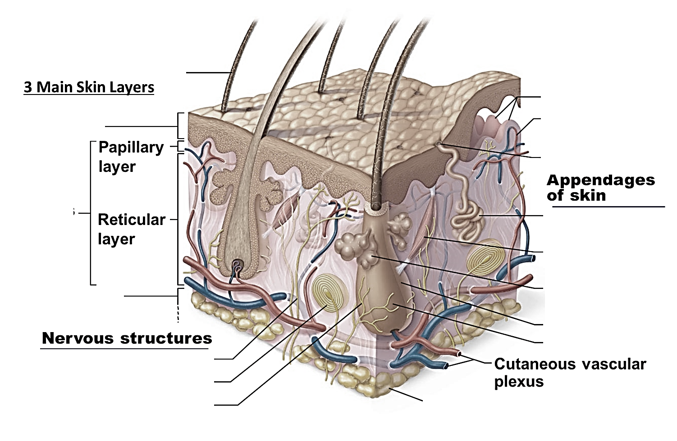
Instructions: Label all the necessary structures seen in the diagram below. Also, explain the physiology behind each structure – here or (if you write with big font) on a separate sheet. Finally, determine what type of tissue each of the three main layers is composed of (remember there are four main types of tissue and we have only looked at epithelial tissue in depth). Write the tissue type next to the layer.

Use your text book or the notes to label the layers of the skin’s epidermis. Please elaborate on all physiology behind each layer.
