Name:____________________________________________________ Per:_____ Date:_____________
Major Skeletal Muscle Groups – Movement and Classifications
Anatomy and Physiology
Arrangement of Fascicles 5 Golden Rules of Muscle Movement
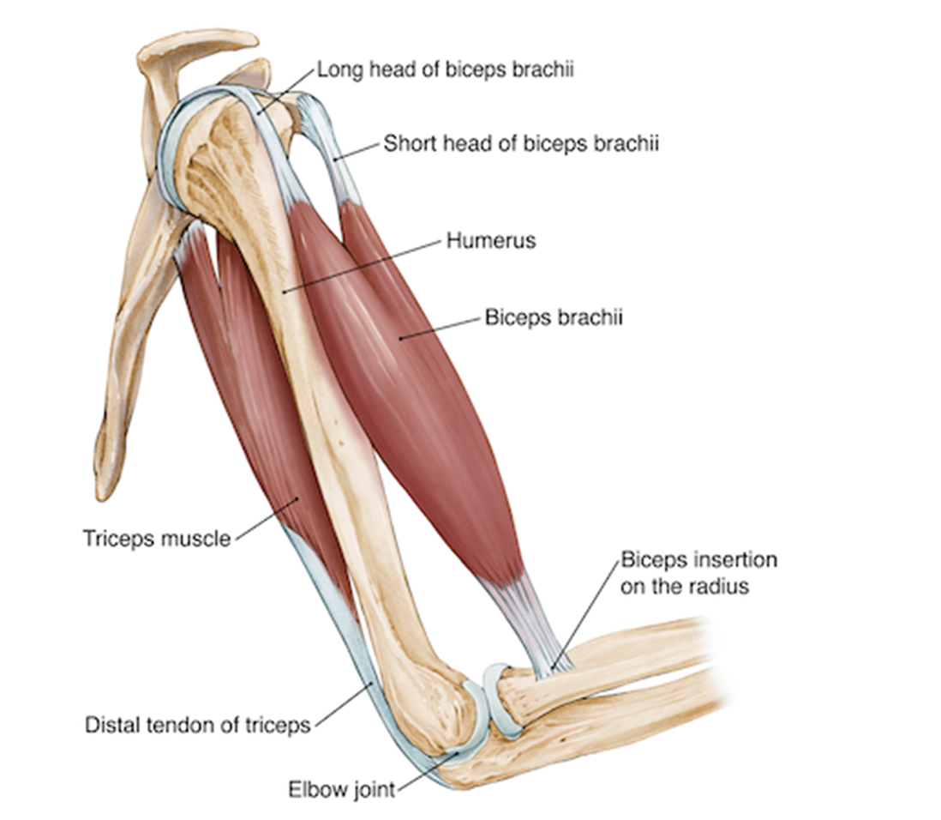
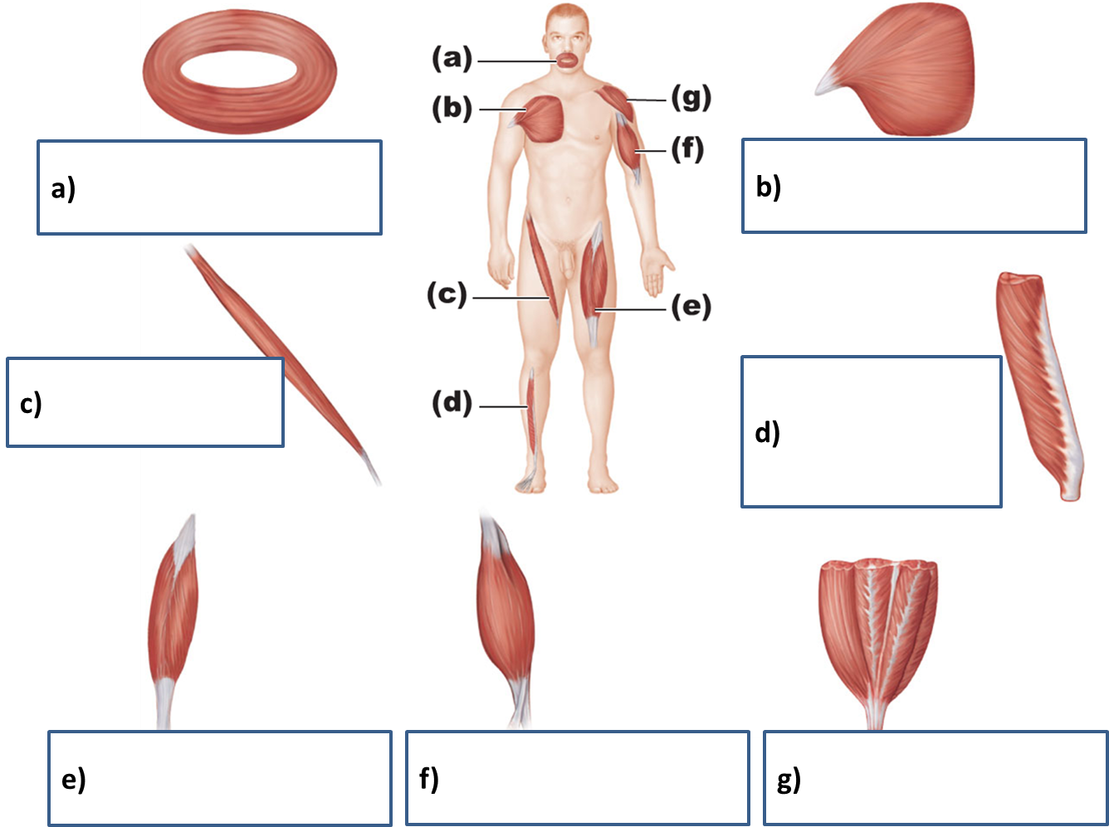

(5 Golden Rules)
1)
2)
3)
4)
5)
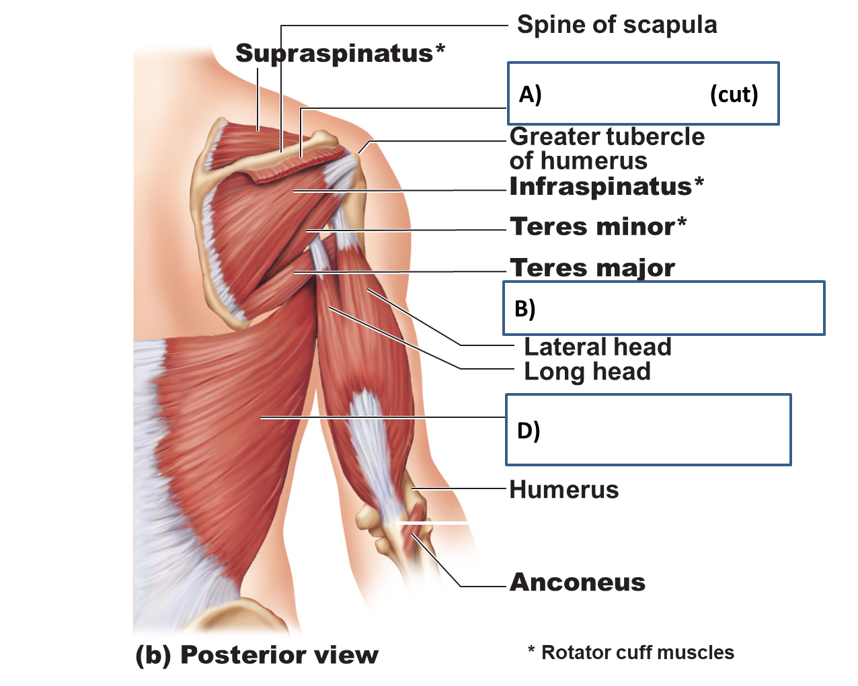
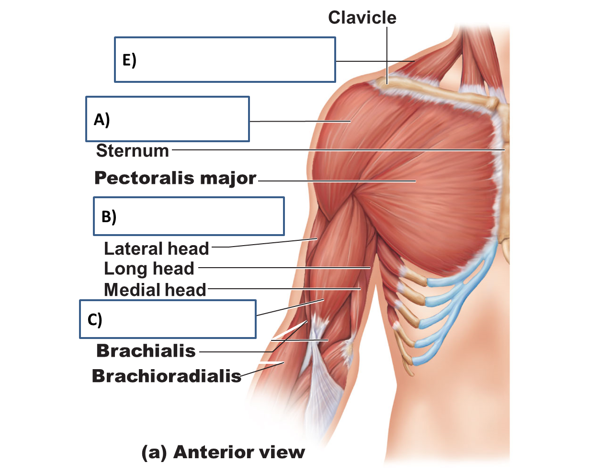

Muscle | Origin | Insertion | Action | Innervation
A)

B)

C)

D)

E)

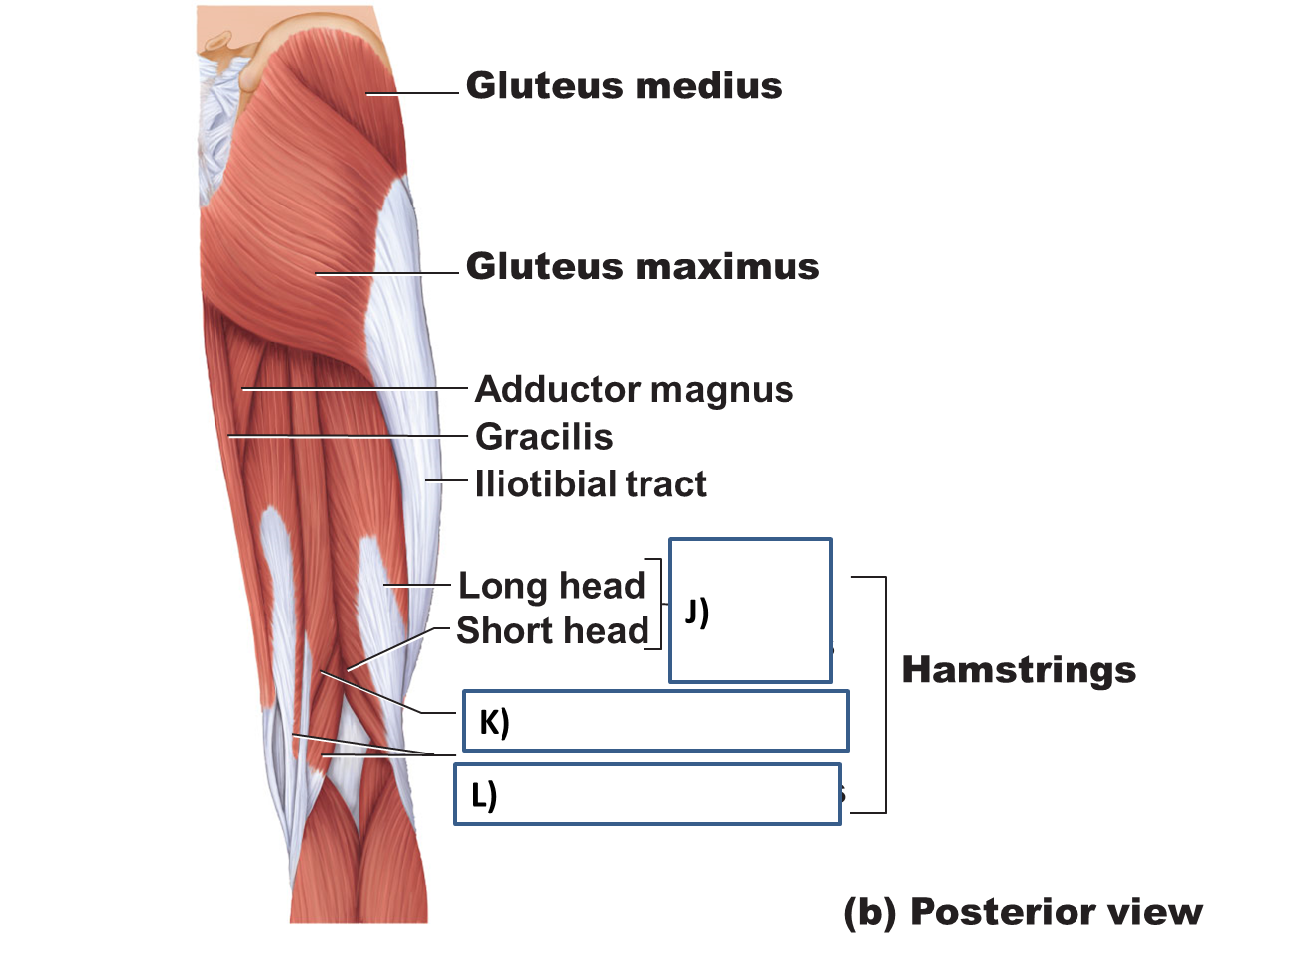
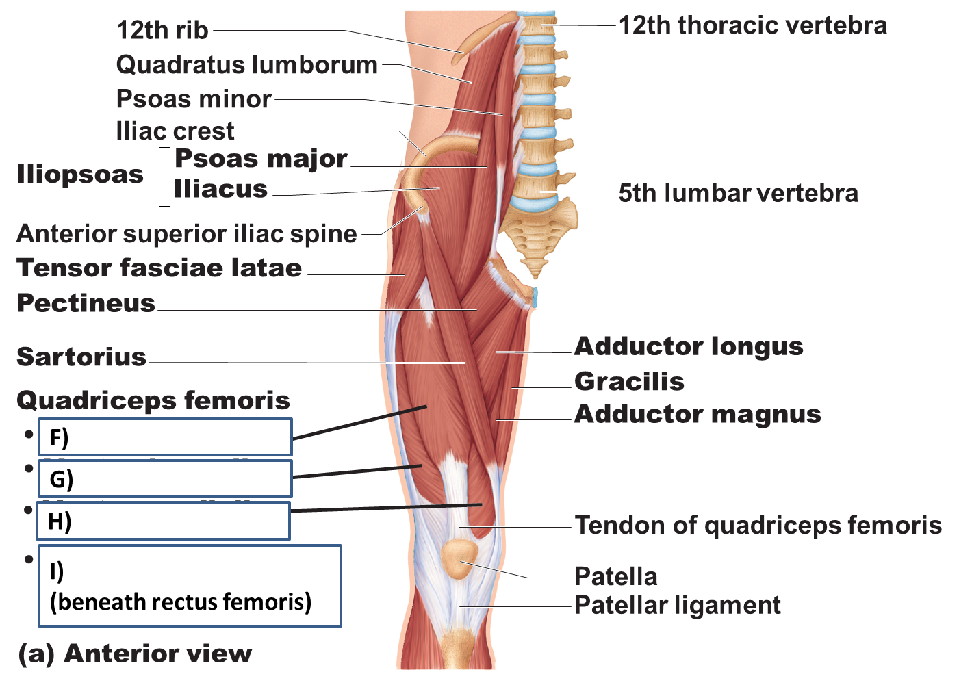

Muscle | Origin | Insertion | Action | Innervation
F)

G)

H)

I)

J)

K)

L

