Name:_____________________________________________________________ Unit:_________________________ Date:_________ Pd:___
Mini Lab Series: Digestion and Biological Reactions
CP A & P

Lab A: Salivary Buffering and pH in the Body (in-class, data only)
Data: | 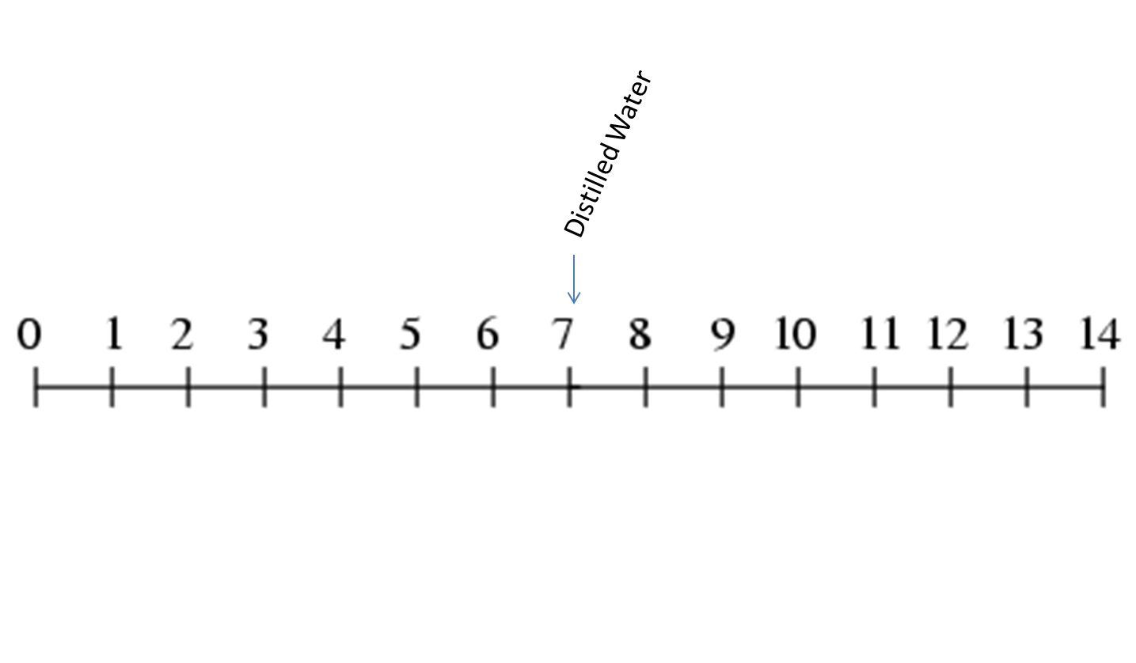
   | Food Ingredient or Material | pH | Acid, Base, or Neutral
  1 | Tap Water
  2 | Distilled Water
  3 | White Vinegar (5% strength)
  4 | Milk
  5 | Lemon-lime soda pop
  6 | Baking Soda (NaHCO₃ dissolved in water)
  7 | Cranberry-Apple Juice
  8 | Lemon Juice
  9 | Powdered Orange Drink
  10 | Honey dissolved in distilled water
  11 | Coffee
  12 | Saliva
  13 | Saliva after
 | Analysis:  1) Record the names of the 12 food materials along the pH scale below. Distilled water has been labeled as an example. Also, label the pH scale with the following: “most basic”, “neutral”, and “most acidic”  2) Based on the results from the baking soda, how does the addition of baking soda to toothpaste reduce the risk of demineralization?  2) It is well known that sugary foods are known to cause tooth decay. Explain how sugar in foods actually results in a lowering of the pH of the mouth, which directly causes cavities (hint: think about salivary buffering reading assignment) | 3) What is the pH of saliva before and after eating the candy?  Before: Immediately after:  ~15 minutes after:  4) Pick one of the many functions of saliva AND describe how your body goes through the series of homeostatic balance: (use “homeostatic balance terminology”)  5) How many times more acidic in lemon juice than distilled water? Show your work.

Lab B: Enzyme Specificity (Enzymes and substrate)
Procedure (Part 1) :
Part 1 – Identifying Dairy Milk From the Three Unknown
You are a lab manager at a company called Pharmex. A lab technician who reports to you has poured all of the last milk samples into three unlabeled containers and forgot which one is which. As the lab manager, you have to determine which sample is which. The three options are cow milk (contains lactose), soy milk (contains sucrose) and rice milk (contains glucose).
- Label test tubes A, B, C,
The rest of the procedure is for you to create. Your materials Include: 1) the three milk samples 2) lactase tablets 3) test-tubes 4) glucose test strips 5) pipettes. HINT: it would be a good idea to determine what carbohydrate classification each substance’s sugar is.
- Always wait 2 minutes before recording glucose test results.
Sample number | Test Color BEFORE adding lactase | Glucose Present? BEFORE | Test Color AFTER adding lactase | Glucose Present?  After | Conclusion: Milk type
1

2

3

- What is the purpose of the glucose strips? Be specific to this lab:

- What effect does the lactase have on cow’s milk (ANSWER WITH A DIAGRAM ONLY)

- Which sample is cow’s milk? How do you know?

- Draw a simple diagram to show what the lactase would look like with the sugars in solutions of SOY JUICE, or RICE JUICE:

Lab C: “The Value of Villi” – In Class Calculations
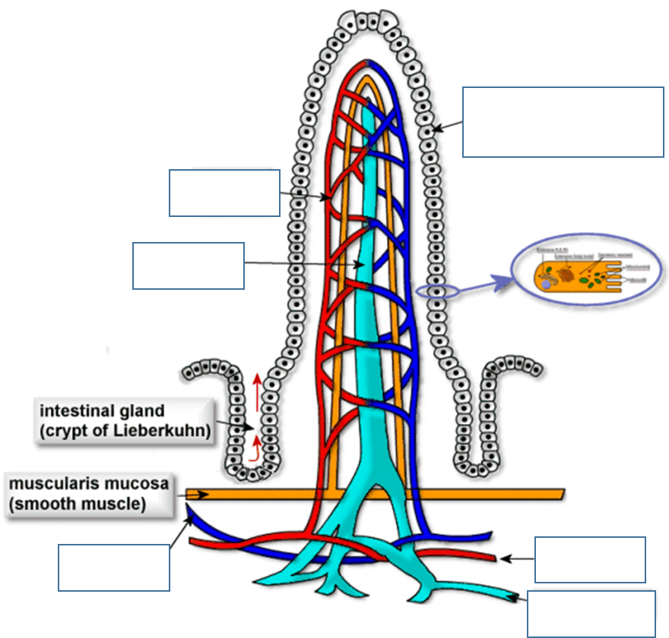
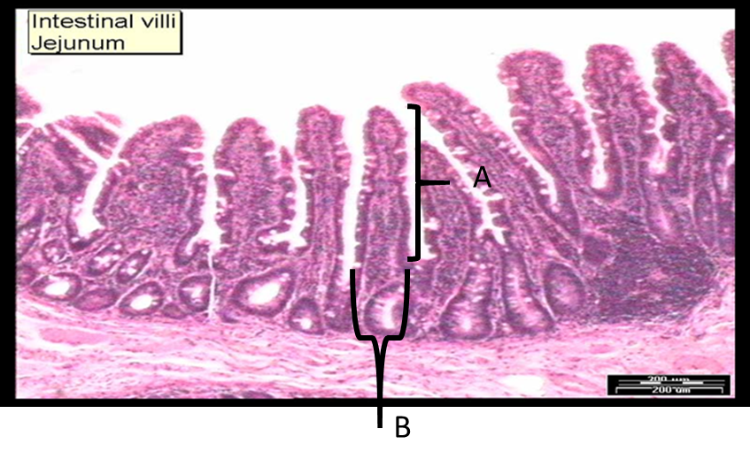

 | Length along edge (a) | Length Below (b) | Ratio of increased length
Villi
Microvilli
1.) How many times longer is the edge of the intestine with the villi than the length of the intestine without the villi? (convert the fraction to decimal form).
Ratio of increase in length = length along edge/length below villi =
2) Calculate the increase in length caused by the microvilli. Record your results in the table above. Use the same ratio as the villi:

3) If the length of the intestine is three meters, how long is the surface of the intestinal lining if you travel along the edges of the villi and microvilli? (show your calculations below.)

4) CONNECTION: Describe another feature of the human anatomy that exploits surface area like the microvilli of the intestine do:

Lab D: Enzyme Specificity (Enzymes and Temp.)
Determine Effect of Temperature on Lactase Activity
It must be determined whether the Lactase tablets can remain active in a variety of temperatures. The temperatures that you will be testing are: Freezing (ice water), boiling, and room temperature.
- For this experiment you will obtain three test tubes.
- Using the correct pipette, add 1 mL of lactase solution (after shaking well) to test tubes.
- Place test tubes into their corresponding “baths”. Please be careful when using the hot water bath. Use appropriate safety materials.
- After allowing test tubes to sit for 10 minutes, mix milk in.
- Conduct glucose test after carefully mixing new solutions.
- Always wait at least 2 minutes before recording glucose test results (let test stripes sit).

Temperature Condition | Actual Temp. | Relative amount of glucose after adding lactase
Ice
Room Temperature
Boiling Water
1. Which temperature represents the control?

2. What is the optimum temperature range for Lactase? How do you know?

3. Explain the difference in enzyme activity at varying temperatures. What happened to the enzymes?

4. Many different ice cream companies add strong acids (like lemon) to their flavors, yet lactase will still work in low pH where many enzymes wont. Predict why this can be observed:

Salivary Buffering Background Information:
There are so many different foods and food ingredients that can cause tooth demineralization and decay. There is also a lot of misconception about what is directly leading to these health issues. By examining oral pH, one can determine which substances increase the risk for tooth demineralization.

Purpose:
To determine the direct cause of tooth demonetization and to learn which foods/drinks lead to an increased risk of oral health problems.

Important information:
The pH scale ranges from 0-14. The lower the pH, the greater the hydrogen ion concentration, and, therefore the greater the acidity of a solution. The higher the pH, lower the hydrogen ion concentration, which indicates an alkaline, or basic solution. A pH of 7 is midway between 0-14 and is neither acidic nor basic, but neutral.
Also remember that for each pH increment change the acidity or basicity changes by a factor of 10. For instance, a pH of 2 is 100 times (10x10) more acidic than a pH of 4.

