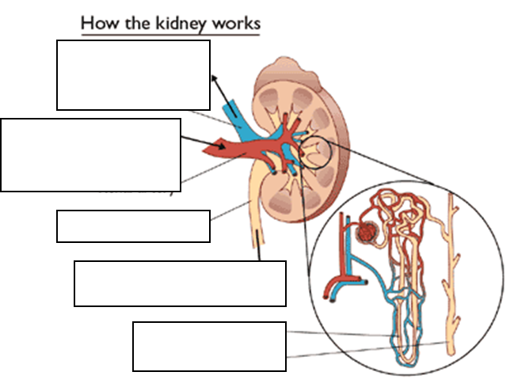**Notes – Urinary System** Name:____________________ Date:__________ Pd:_____

