Name:______________________________ Unit:_________________________ Date:_________ Pd:___
Practice: Additional Skin Items
Complete the missing labels for both parts of the diagram (5 for first view, and 11 for cross section)
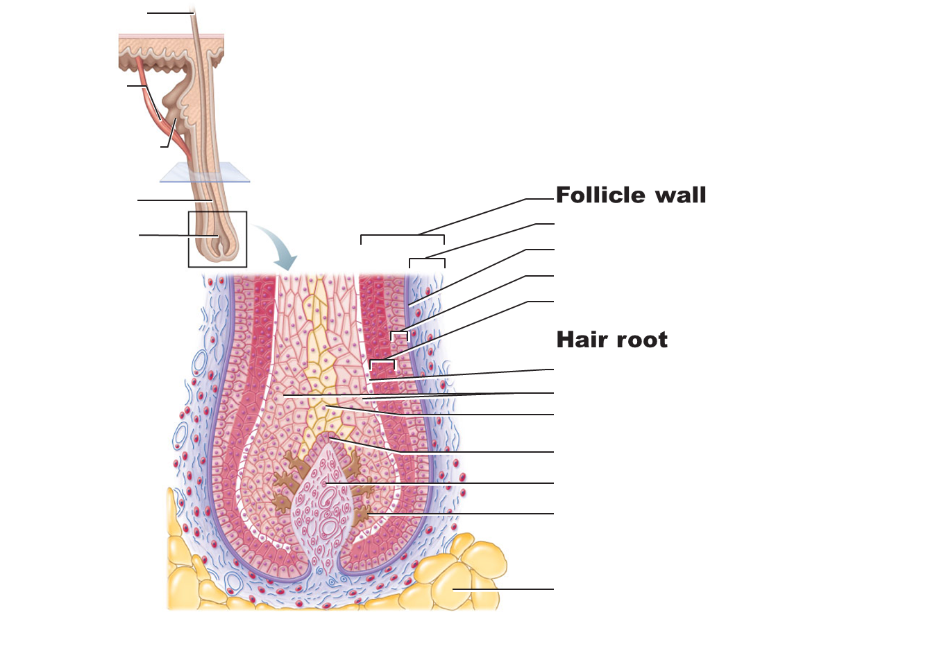
CP A & P

Homeostatic imbalances of the skin:
- The first section reviews the severity of burns. Using key choices, select the correct burn type for each of the following descriptions. Enter the correct answers in the answer blanks:

Key Choices

A. First-degree Burn B. Second-degree Burn C. Third-degree burn

____________________ 1) Full thickness burn; epidermal and dermal layers destroyed; skin is blanched

____________________ 2) Blisters form

____________________ 3) Epidermal damage, redness, and some pain; (usually brief)

____________________ 4) Epidermal and some dermal damage; pain; regeneration is possible

____________________ 5) Pain is absent because nerve endings in the area are destroyed

____________________ 6) Regeneration is impossible, requires grafting

7) What is the importance of the “rule of nines” in treatment of burn patients?

8) Fill in the type of skin cancer which matches each of the following descriptions:

____________________________ a. Epithelial cells, not in contact with the basale layer

____________________________ b. Cell of the lowest level of the epidermis invade the dermis and hypodermis; exposed areas develop ulcer; slow to metastasize.

____________________________ c. Rare, but often deadly cancer of pigment-producing cells.

9) What does ABCD mean in reference to examination of pigmented areas?

10) Burn area practice problems:

- While trying to evade batman and other assailants, Jack Napier falls into a vat of chemicals and receives several first and second degree burns. Specifically, he burned his entire head and neck, his posterior trunk, both his anterior upper limbs, and his entire right leg. What percent of his body was burned? Show your work (create a bullet point list with %)

- Before he began haunting nightmares, Freddie was your average run-of-the-mill serial killer- until he was trapped in boiler room and got some burns. His anterior face and neck was burned, both arms (only posterior), the anterior left leg, and posterior right leg. What percent of his body was burned?

Appendages of the Skin Practice
11) Using key choices, complete the following statements. Insert appropriate letter(s) or term(s) in the answer blanks.

Key Choices
A. Arrector pilli B. Hair C. Sebaceous glands D. Sweat Glands (eccrine)
E. Cutaneous receptors F. Hair follicle(s) G. Sweat glands (apocrine)

___________ a. A blackhead is an accumulation of oily material produced by.

___________ b. Tiny muscles attached to hair follicles that pull hair upright during fright or cold are called….

___________ c. The most numerous variety of perspiration glad is the ….

___________ d. A sheath formed of both epithelial and connective tissues is the ….

___________ e. A less numerous variety of perspiration glad is the _______. Its secretion (often milky in appearance) contains proteins and other substances that favor bacterial growth.

___________ f. ______ is found everywhere on the body except the palms of the of the hands, soles of the feet, and lips, and primarily consists of keratinized cells.

___________ g. _______ are specialized nerve endings that respond to temperature and touch, for example.

___________ h. _______ become more active at puberty

___________ i. Part of heat-liberating apparatus of the body is the…..

