Name:______________________________ Unit:_________________________ Date:_________ Pd:___
Labeling: Anatomy of a Long Bone
Identify the function of all the structures shown in the diagram:
1) Endosteum:

2) Yellow bone marrow:

3) Compact Bone:

4) Nutrient arteries:
CP A & P
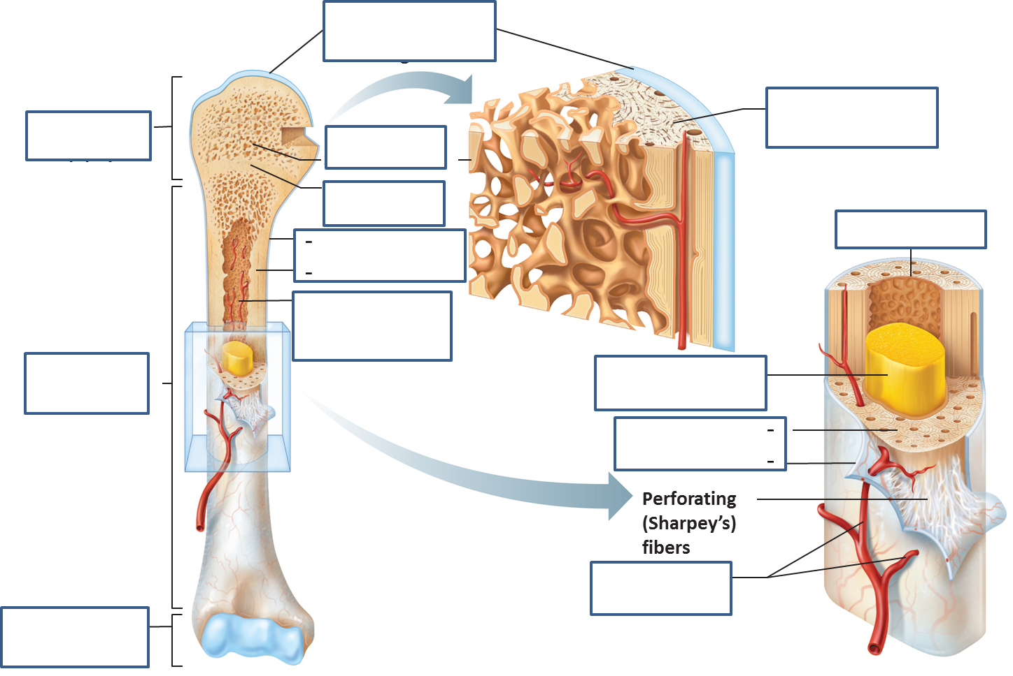
5) Articular Cartilage: 7) Diaphysis: 9) Periosteum

6) Proximal Epiphysis: 8) Spongy Bone: 10) Medullary Cavity:

