Name:__________________________________________________________ Unit:_________________________ Date:_________ Pd:___
Practice: Respiratory Structures
CP A & P
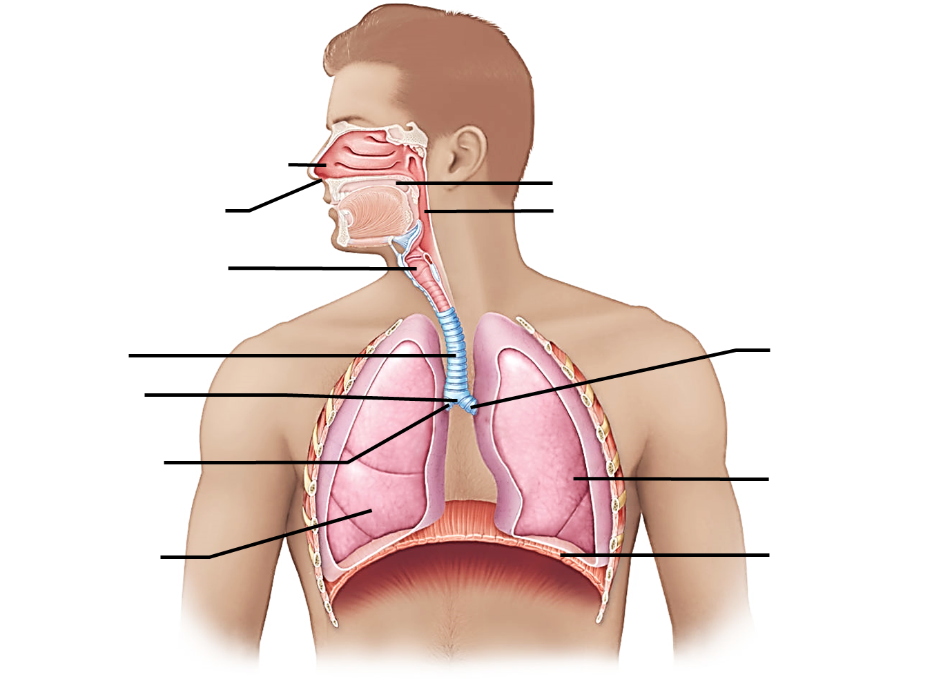
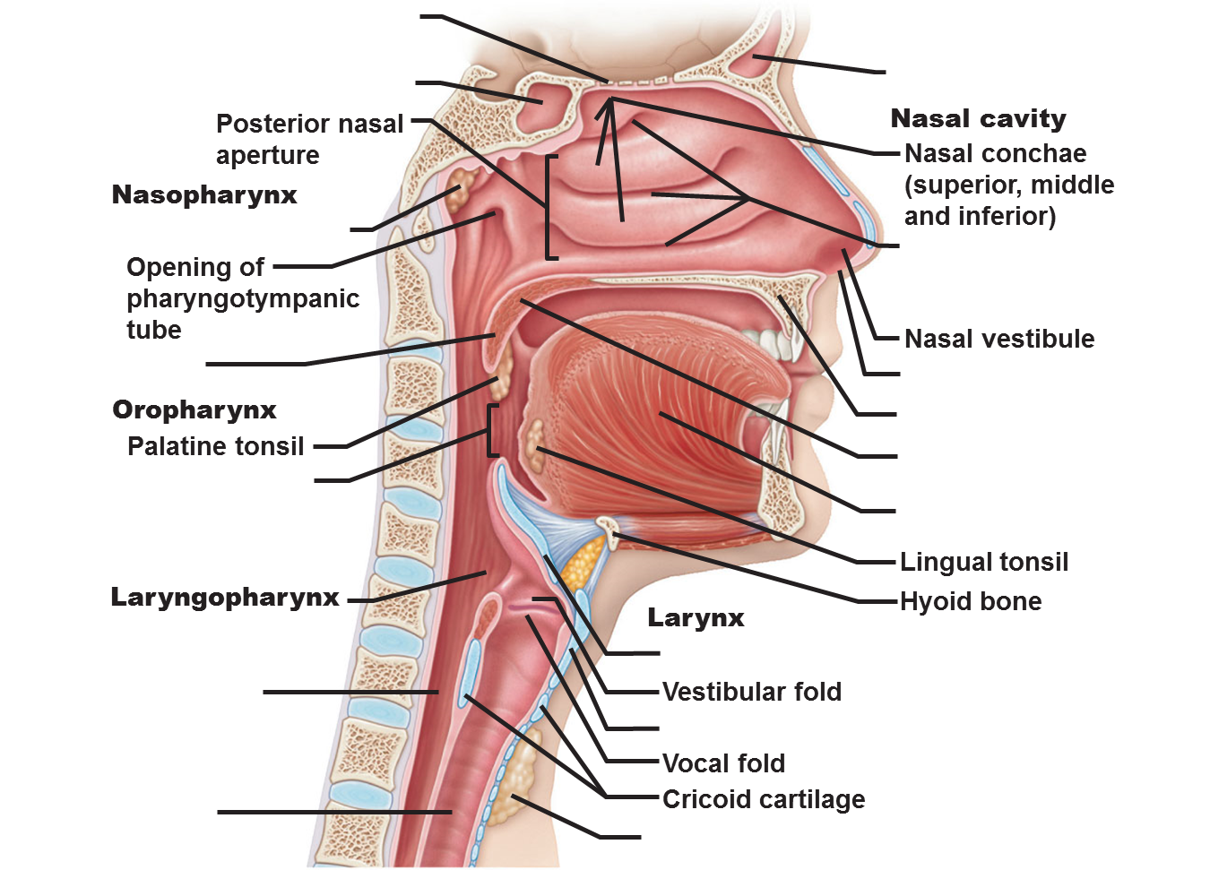
Basic Gross Anatomy:

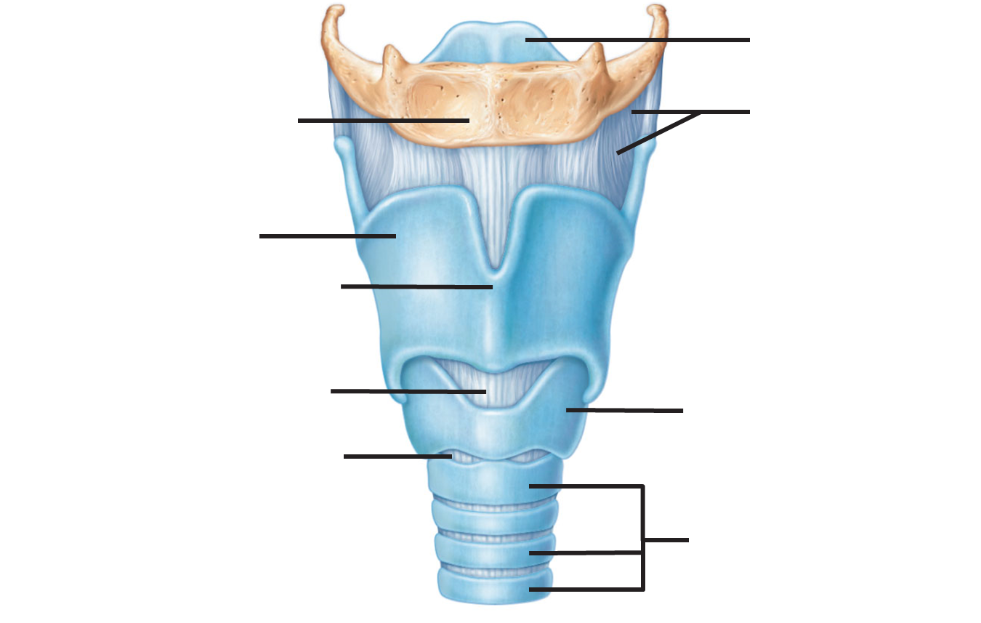

1) List the pathway of air from the outside world to the point where gas diffusion happens with the blood in the lungs.

2) Define the Following:
- Pulmonary Ventilation

- External Respiration:

- Transport

- Internal Respiration

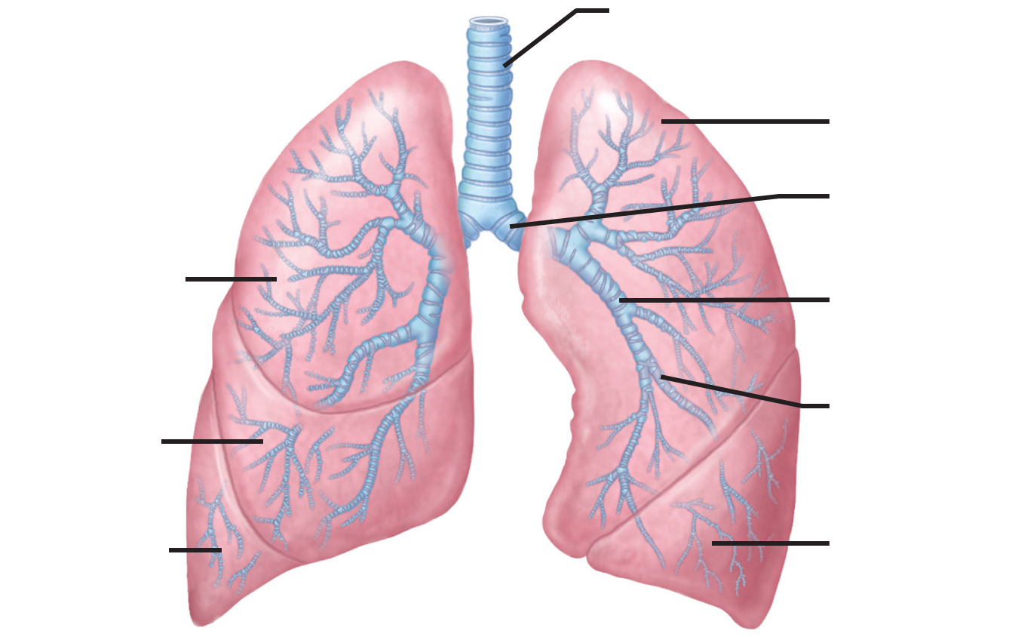
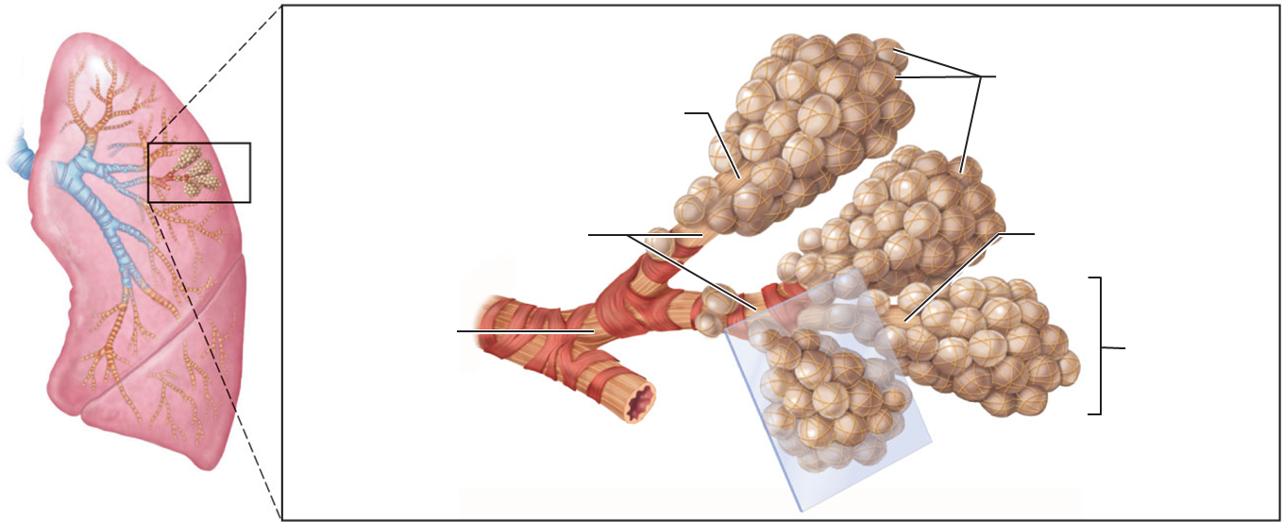

Microscopic Anatomy:

