Name:_____________________________________________________________ Unit:_________________________ Date:_________ Pd:___
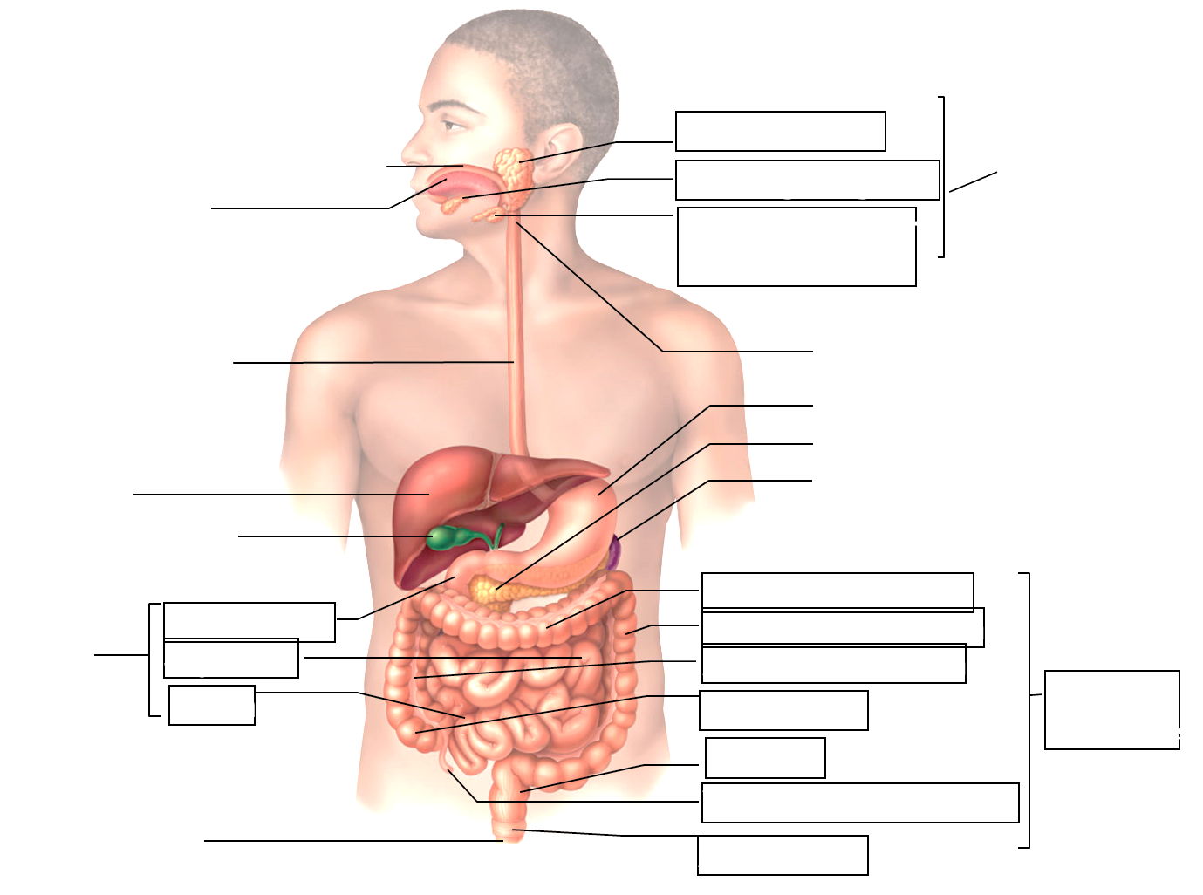
Practice: Labeling Structure of the Digestive System and Biomolecule Journey
Additions:
1) OUTLINE (with color) all structures that help with MECANICAL DIGESTION

2) OUTLINE (diff. color) all structures that help with CHEMICAL DIGESTION.

CP A & P

