Name:________________________________________ Unit:_________________________ Date:_________ Pd:___
Practice: Labeling Parts of the Eye
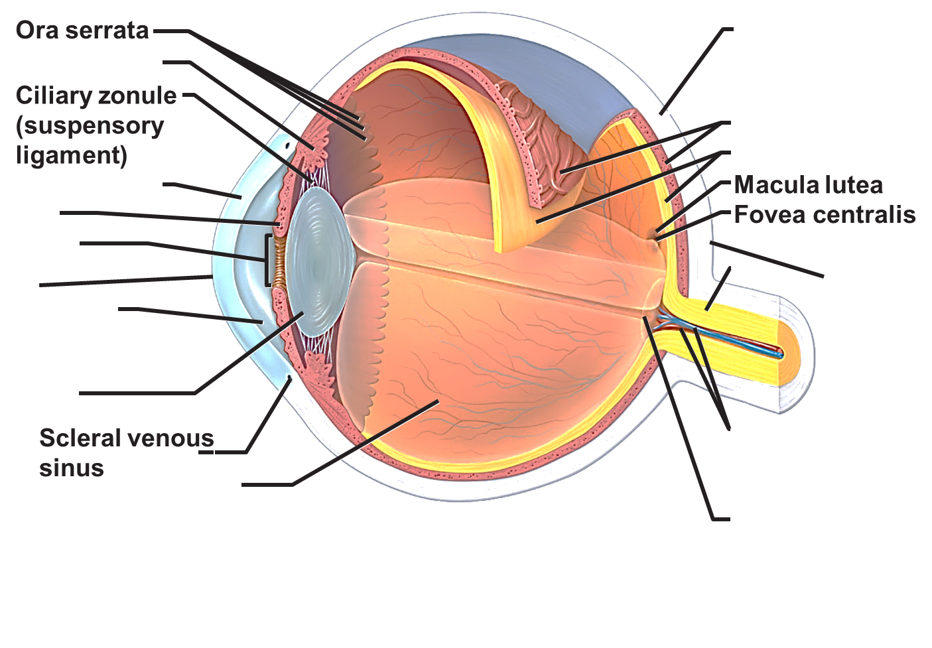
CP A & P

Structure: |  | Anatomical Features/Special Characteristics | Physiology
Conjunctiva

Lacrimal Apparatus

Fibrous Layer | Sclera
Fibrous Layer | Cornea
Vascular Layer | Choroid Layer
Vascular Layer | Ciliary Body
Vascular Layer | Iris
Retina

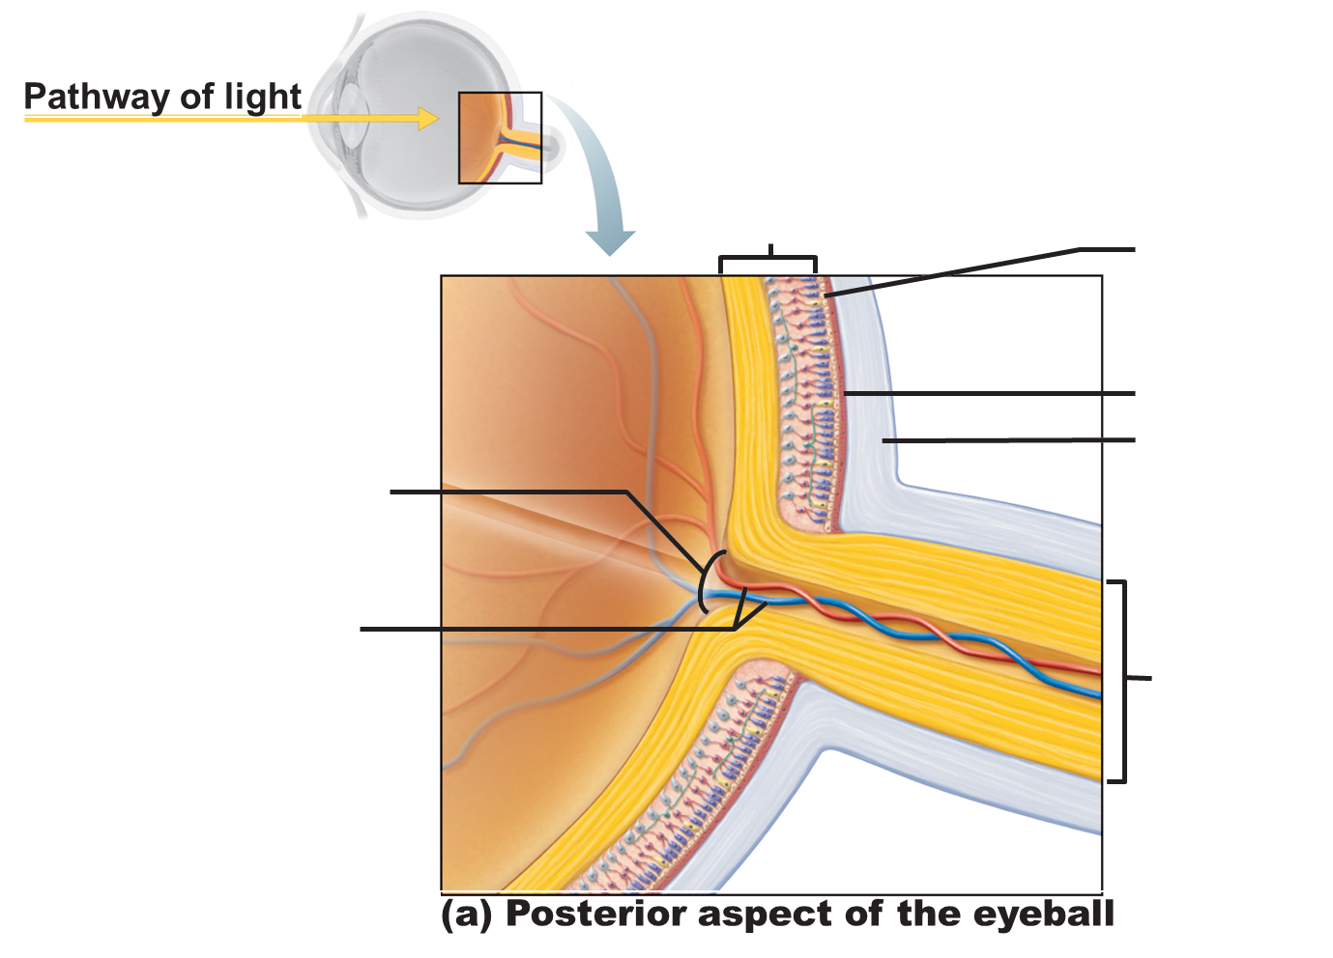

Describe the function of the items that were labeled above but not included in the chart on the front page (3 structures should be listed)
1)

2)

3)

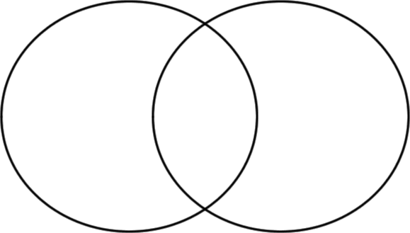
Photoreceptor Cells: (Compare and Contrast RODS AND CONES)

