Name:______________________________ ________ Unit:_________________________ Date:_________ Pd:___
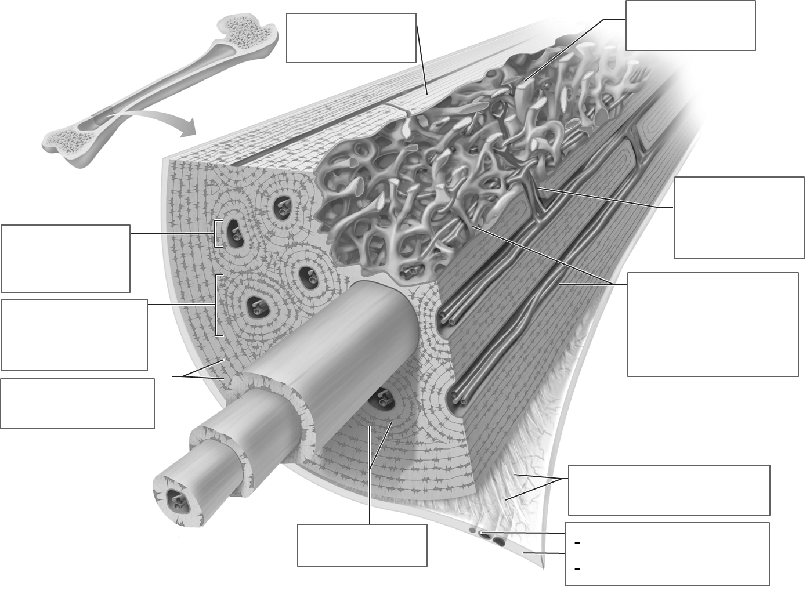
Practice: The Inner Workings of Compact Bones -
CP A & P
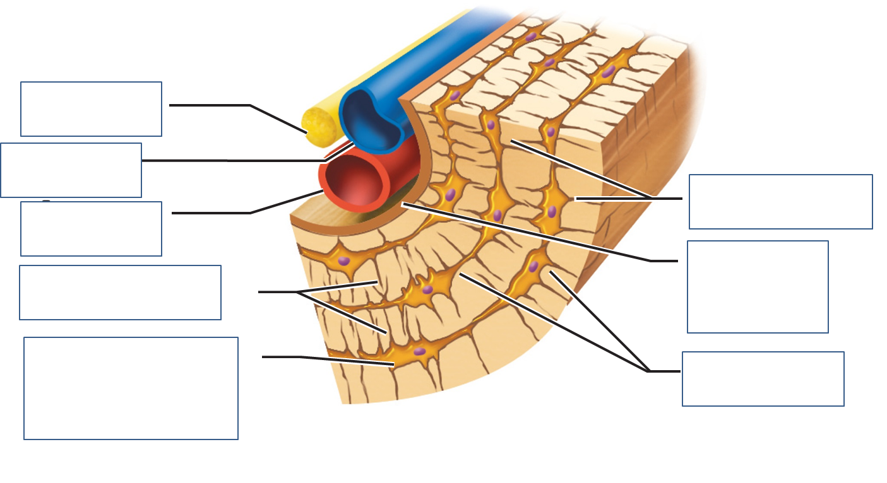
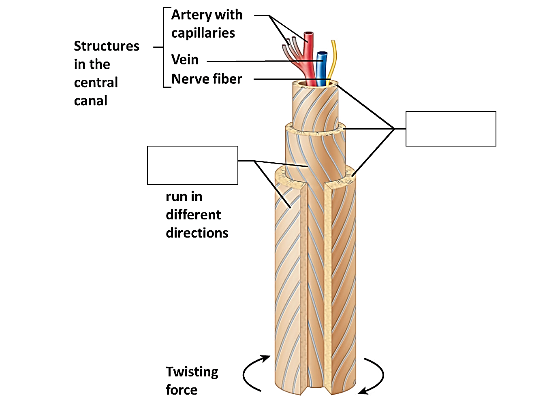

Define:

- Central (Haversian) Canal:

- Osteon:

- Endosteum:

- Periosteum:

- Lamallae

- Canaliculi (Canaliculus)

- Lacuna

