Name:________________________________________ Unit:_________________________ Date:_________ Pd:___
Practice: Bone Fractures
CP A & P

Using the key choices, identify the fracture (fx) types shown in the figure below and the fracture types and treatments described below. Enter the appropriate key let on the term in each answer blank.

Choices:
A. Closed reduction D. Depressed fracture G. Simple fracture

B. Compression fracture E. Greenstick fracture H. Spiral Fracture

C. Compound Fracture F. Open reduction I. Comminuted

___________________1) Bone is broken cleanly; the ends do not penetrate the skin

___________________2) Nonsurgical realignment of broken bone ends and splinting of the bone

___________________3) A break common in children; bone splinters, but break is incomplete

___________________4) A fracture in which the bone is crushed; common in the vertebral column

___________________5) A fracture in which the bone ends penetrate through the surface

___________________6) Surgical realignment of broken bone ends

___________________7) A result of twisting forces

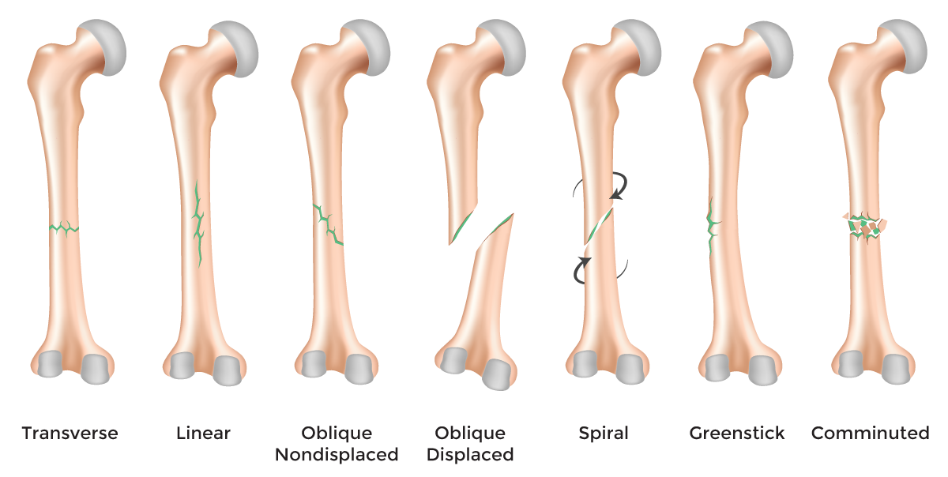
___________________8) Bone fragments into three or more pieces; common in aged bones

Options: A. Linear B. Comminuted C. Oblique Displaced D. Spiral E. Greenstick

F. Transverse G. Oblique Nondisplaced

Practice: Bone Healing

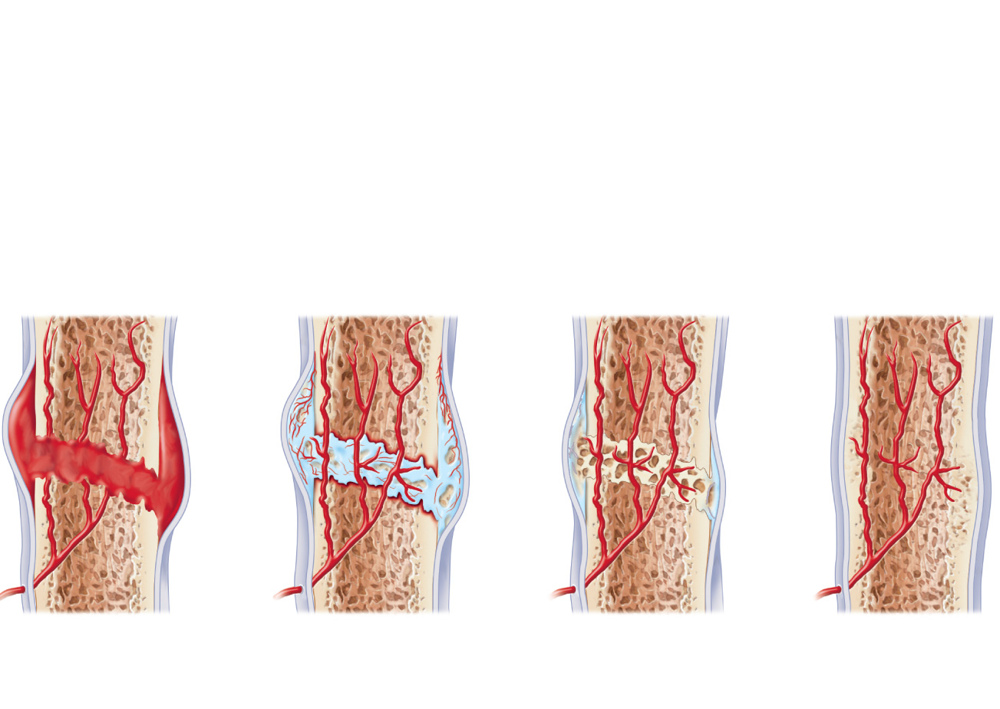
- Label the necessary steps and structures below. Also, record what happens in each step

