Name:________________________________________ Unit:_________________________ Date:_________ Pd:___
Practice: Blood Vessel Basics
CP A & P (p. 360)
1) How did the Greeks believe blood traveled through the body?

2) When and who proved that blood moves in circles (circulatory paths)?

3) Put these vessels in order from leaving the heart to returning to the heart (veins, capillaries, arterioles, venules, arteries).

4) Name the 3 tunics of vessels from inner to outer:

5) Match the correct tunic with the statements below:

a. _____ lines lumen A. Tunica intima
b. _____ composed of fibrous connective tissue B. Tunica Media
c. _____ bulky middle layer C. Tunica externa
d. _____ thin layer of epithelium
e. _____ function of support and protection
f. _____ mostly composed of smooth muscle
g. _____ forms slick surface to reduce friction
h. _____ responsible for changing the diameter of the vessels

6) Math the correct vessel with the statements below

a. _____ usually under high pressure A. Artery
b. _____ one layer thick B. Vein
c. _____ usually flows against gravity C. Capillaries
d. _____ larger lumen
e. _____ thicker walls
f. _____ contain 3 tunics
g. _____ exchange happens here
h. _____ heavier tunica media
i. _____ thin walls
j. _____ use skeletal muscles to move blood
k. _____has valves
l. ______ able to expand and recoil
m. _____ low pressure
n. _____ typically more superficial
o. _____ connection of arterioles and venules
Use the info from 9.1 Warm-Up to Complete (“Start Here”)
Anti-Serum  Result | Patient 1  (Record results and image of contents of test tube) | Patient 2  (Record results and image of contents of test tube) | Patient 3  (Record results and image of contents of test tube)
A

B
Rh factor

Blood Type Result

Practice: Labeling Major Arteries and Veins in Systemic Circulation
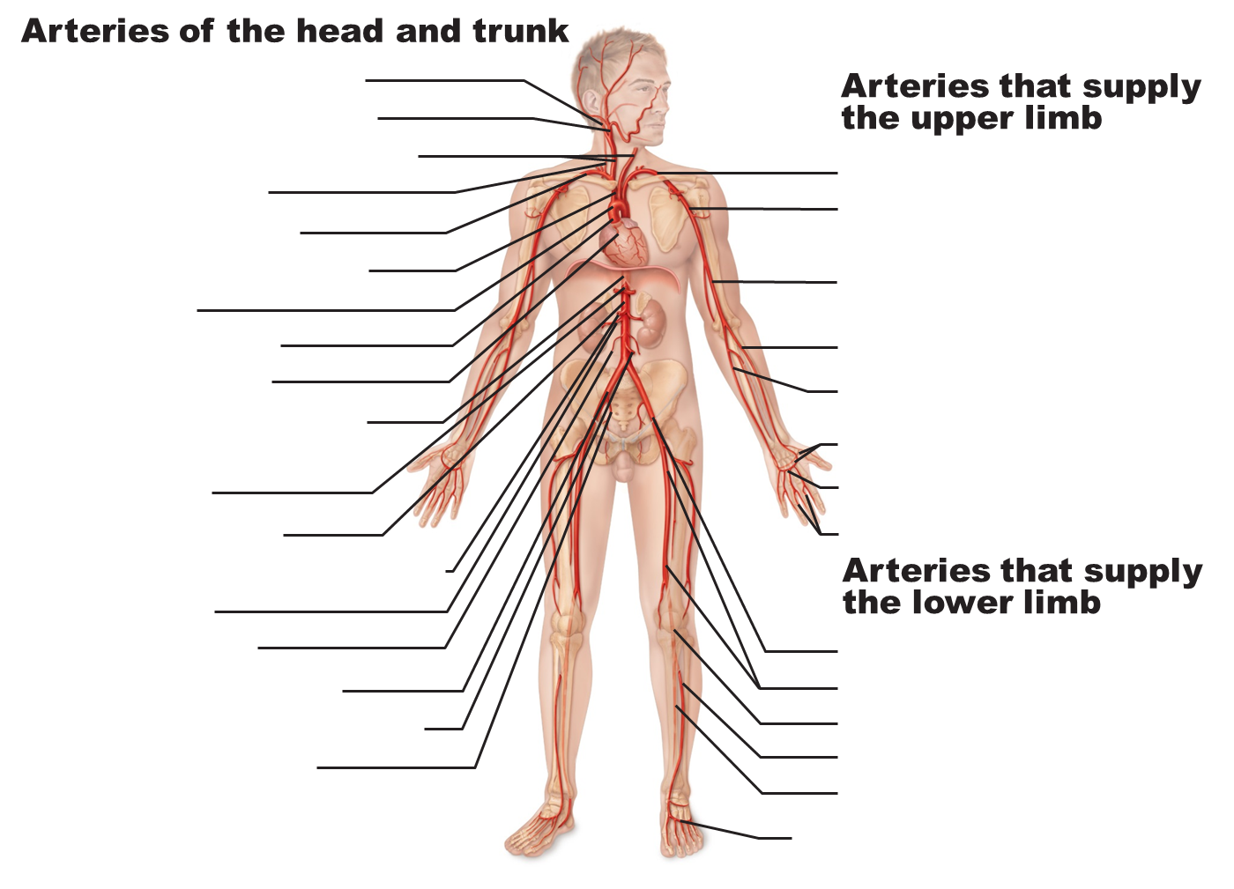
CP A & P

