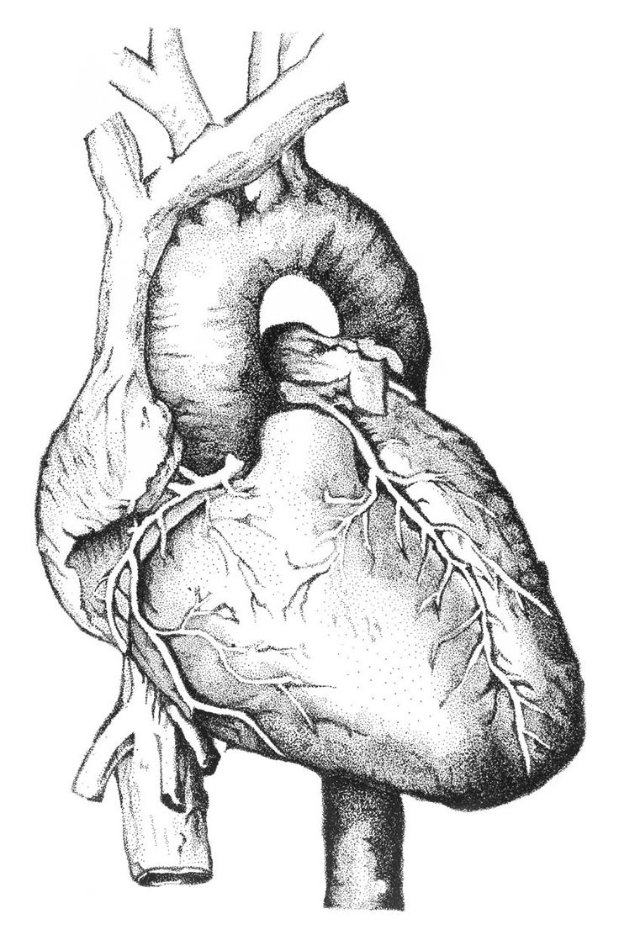
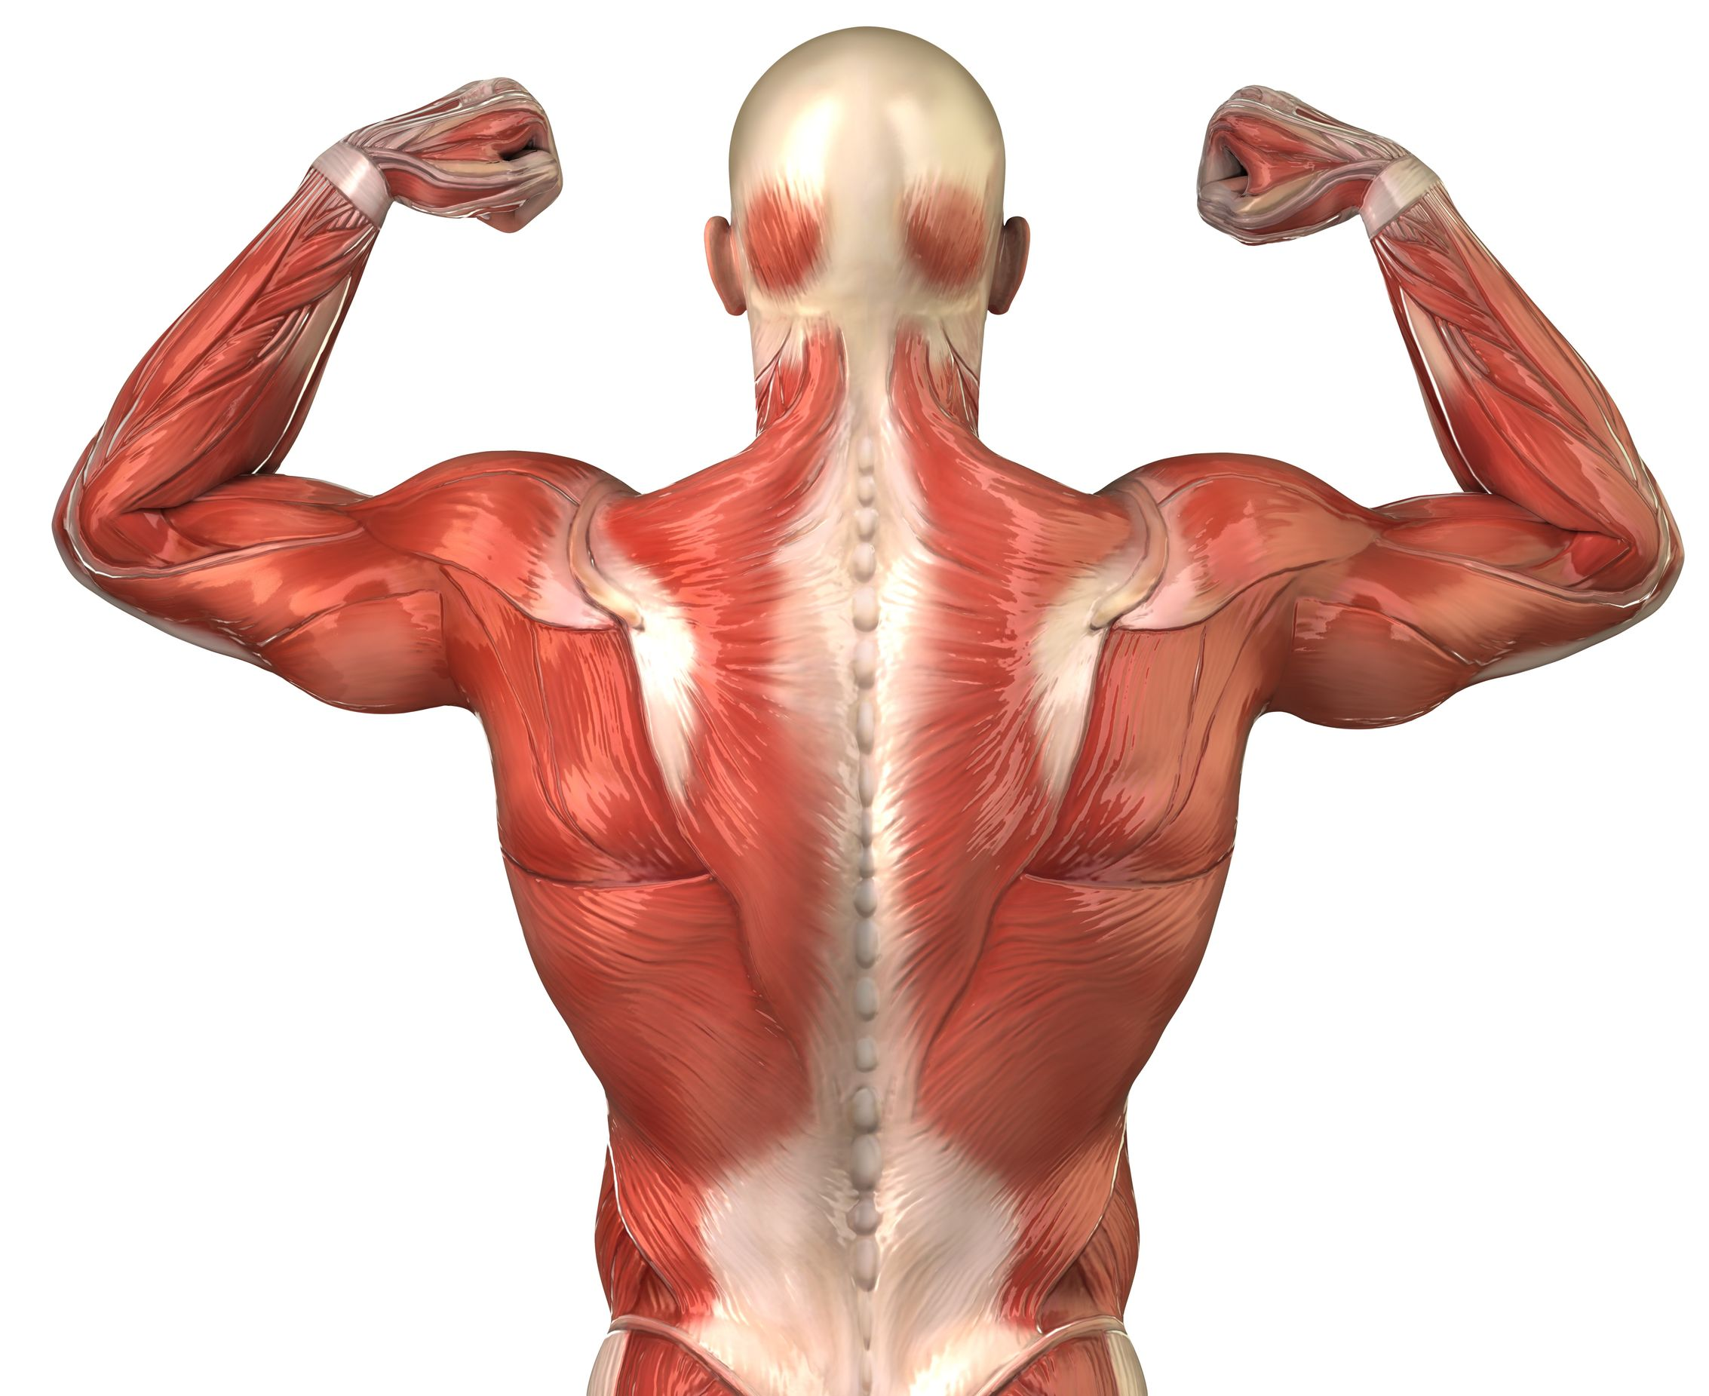
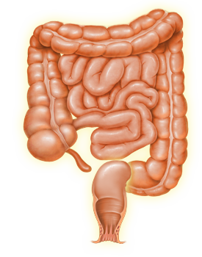
Name:___________________________________________________ Unit:_________________________ Date:_________ Pd:___
Comparing Muscle Types
CP A & P

Muscle type ----------- | Skeletal | Smooth | Cardiac
Shape of the Cell (Description and Color Drawing)

Location of Nucleus/Nuclei (w/in cell)

Speed of Contraction (Rank – 1 – 3, fast to slow)
Presence of striations (yes/no)

Location(s) within body

Voluntary/Involuntary?

Innervation needed? If no, explain why:

