Name:___________________________________________________ Unit:_________________________ Date:_________ Pd:___
Unit 5: Skeletal System
Module Guide

Module 5.1 | Module 5.2 | Module 5.3
  _____________________________ | 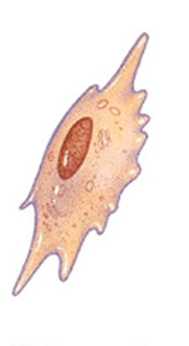  ______________________________  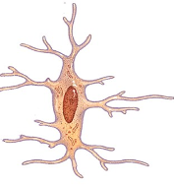  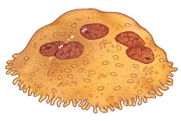  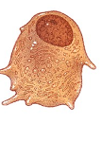 | ______________________________

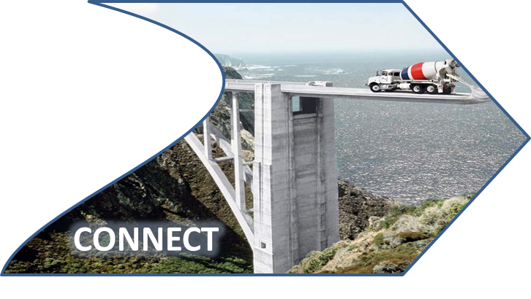

Unit 5: Skeletal
Essential Connections: Medical/Health Connection(s):
(notes):
- _________________________________________________________________________________________________________________________________________________________________________________________________________________________________________________________________________________________________________________________________________________________________________________________________________________________________________________________________________________________________________________________________________________________________________________________________________________________________________________________________________________________________________________________________________________________________________________________________________________________________________________________________________________.

Unit 5 Additional Notes: Body Systems Connections
- “Origins of Us” – Human Skeletal System Evolution

